ReactJS Hands-On Lab Submission
Name: [Your Name]
Course: React JS
This document contains my solutions and screenshots for all 5 React JS hands-on labs.

Lab 1 - Setting up React environment (myfirstreact)
Task: Create a new React app named "myfirstreact" that prints "welcome to the first session of React" as a heading.

Steps I did
1. Installed Node.js and npm, then installed create-react-app.
2. Ran: npx create-react-app myfirstreact
3. cd myfirstreact
4. Opened the project in VS Code, opened src/App.js and replaced the content.

App.js
import React from 'react';

function App() {
return (
<div>
<h1>welcome to the first session of React</h1>
</div>
);
}

export default App;

5. Ran npm start and opened localhost:3000 in the browser.

Output
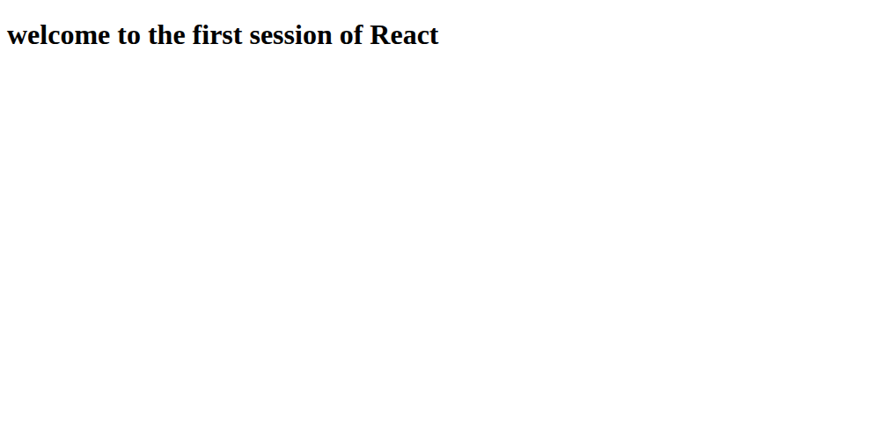

Lab 2 - Creating class components (StudentApp)
Task: Create a React app named "StudentApp" with three components - Home, About and Contact, each showing its own welcome message, and call all three from App.js.

Steps I did
1. Ran: npx create-react-app StudentApp
2. Created a new folder src/Components and added Home.js, About.js and Contact.js inside it.

Components/Home.js
import React from 'react';

class Home extends React.Component {
render() {
return (
<div>
<h2>Welcome to the Home page of Student Management Portal</h2>
</div>
);
}
}

export default Home;

Components/About.js
import React from 'react';

class About extends React.Component {
render() {
return (
<div>
<h2>Welcome to the About page of the Student Management Portal</h2>
</div>
);
}
}

export default About;

Components/Contact.js
import React from 'react';

class Contact extends React.Component {
render() {
return (
<div>
<h2>Welcome to the Contact page of the Student Management Portal</h2>
</div>
);
}
}

export default Contact;

App.js
import React from 'react';
import Home from './Components/Home';
import About from './Components/About';
import Contact from './Components/Contact';

function App() {
return (
<div>
<Home />
<About />
<Contact />
</div>
);
}

export default App;

Ran npm start and checked localhost:3000.

Output
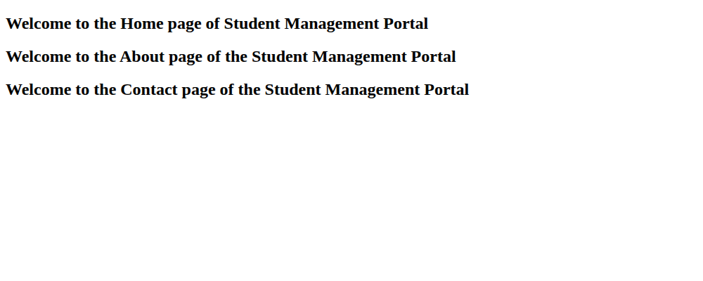

Lab 3 - Function component with styling (scorecalculatorapp)
Task: Create a React app named "scorecalculatorapp" with a function component "CalculateScore" that accepts Name, School, Total and Goal, calculates the average score and displays it, styled using a CSS file.

Steps I did
1. Ran: npx create-react-app scorecalculatorapp
2. Created src/Components/CalculateScore.js and src/Stylesheets/mystyle.css

Stylesheets/mystyle.css
.scoreCard {
width: 320px;
margin: 20px auto;
padding: 20px;
border: 1px solid #333;
border-radius: 10px;
font-family: Arial, sans-serif;
background-color: #f4f9ff;
text-align: center;
}

.scoreCard h2 {
color: #1a5276;
}

.scoreCard p {
font-size: 16px;
margin: 6px 0;
}

Components/CalculateScore.js
import React from 'react';
import '../Stylesheets/mystyle.css';

function CalculateScore(props) {
const { name, school, total, goal } = props;
const average = (total / goal).toFixed(2);

return (
<div className="scoreCard">
<h2>Score Calculator</h2>
<p><b>Name:</b> {name}</p>
<p><b>School:</b> {school}</p>
<p><b>Total Score:</b> {total}</p>
<p><b>Goal:</b> {goal}</p>
<p><b>Average Score:</b> {average}</p>
</div>
);
}

export default CalculateScore;

App.js
import React from 'react';
import CalculateScore from './Components/CalculateScore';

function App() {
return (
<div>
<CalculateScore name="Rahul Sharma" school="Cognizant Public School" total={450} goal={500} />
</div>
);
}

export default App;

Ran npm start and opened localhost:3000.

Output
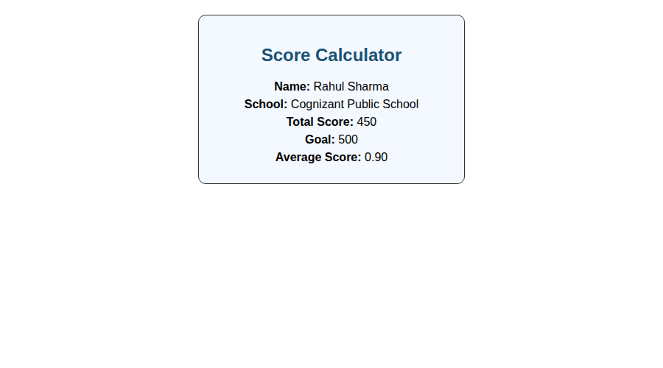

Lab 4 - Component lifecycle - componentDidMount & componentDidCatch (blogapp)
Task: Create a React app named "blogapp" that uses the Fetch API to load posts from https://jsonplaceholder.typicode.com/posts inside componentDidMount(), and shows an alert using componentDidCatch() if something goes wrong.

Steps I did
1. Ran: npx create-react-app blogapp
2. Created src/Post.js and src/Posts.js

Post.js
import React from 'react';

class Post extends React.Component {
constructor(props) {
super(props);
this.title = props.title;
this.body = props.body;
}
}

export default Post;

Posts.js
import React from 'react';

class Posts extends React.Component {
constructor(props) {
super(props);
this.state = {
posts: [],
hasError: false
};
}

loadPosts = () => {
fetch('https://jsonplaceholder.typicode.com/posts')
.then((response) => response.json())
.then((data) => {
this.setState({ posts: data.slice(0, 5) });
})
.catch((error) => {
console.log(error);
});
};

componentDidMount() {
this.loadPosts();
}

componentDidCatch(error, info) {
this.setState({ hasError: true });
alert('Something went wrong while loading the posts: ' + error);
}

render() {
if (this.state.hasError) {
return <h3>Something went wrong.</h3>;
}
return (
<div>
<h1>Blog Posts</h1>
{this.state.posts.map((post) => (
<div key={post.id}>
<h3>{post.title}</h3>
<p>{post.body}</p>
</div>
))}
</div>
);
}
}

export default Posts;

App.js
import React from 'react';
import Posts from './Posts';

function App() {
return (
<div>
<Posts />
</div>
);
}

export default App;

Ran npm start and opened localhost:3000. It fetches the posts from the API on mount and lists the title and body of the first few posts.

Output
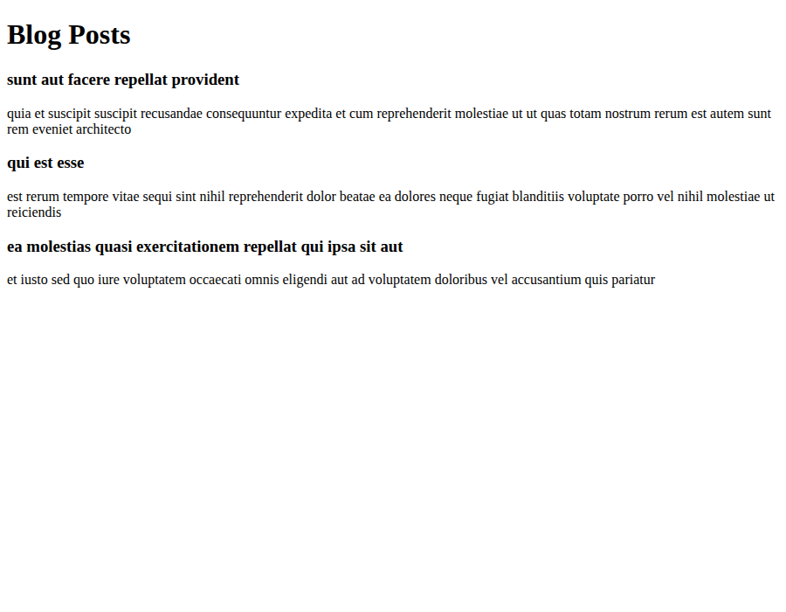

Lab 5 - Styling with CSS Modules (Cohort Dashboard)
Task: Style the given cohort dashboard react app using a CSS Module. The box class needs width 300px, inline-block display, 10px margin all around, 10px top/bottom and 20px left/right padding, 1px black border and 10px border radius. The <dt> tag should have font-weight 500, and the <h3> heading should be green for ongoing cohorts and blue for completed ones.

Steps I did
1. Restored the packages with npm install.
2. Created src/CohortDetails.module.css and defined the box class and the dt tag selector as asked.
3. Imported the CSS Module in the CohortDetails component and applied the box class to the container div, and used a conditional class on the <h3> for the green/blue color.

CohortDetails.module.css
.box {
width: 300px;
display: inline-block;
margin: 10px;
padding: 10px 20px;
border: 1px solid black;
border-radius: 10px;
}

dt {
font-weight: 500;
}

.ongoing {
color: green;
}

.completed {
color: blue;
}

CohortDetails.js
import React from 'react';
import styles from './CohortDetails.module.css';

function CohortDetails(props) {
const { name, startDate, endDate, status } = props;
const statusClass = status === 'ongoing' ? styles.ongoing : styles.completed;

return (
<div className={styles.box}>
<h3 className={statusClass}>{name}</h3>
<dl>
<dt>Start Date</dt>
<dd>{startDate}</dd>
<dt>End Date</dt>
<dd>{endDate}</dd>
<dt>Status</dt>
<dd>{status}</dd>
</dl>
</div>
);
}

export default CohortDetails;

App.js (sample data used to test)
import React from 'react';
import CohortDetails from './CohortDetails';

function App() {
return (
<div>
<h1>Cognizant Academy - Cohort Dashboard</h1>
<CohortDetails name="React JS - Batch 12" startDate="01-Jun-2026" endDate="30-Jun-2026" status="ongoing" />
<CohortDetails name="Java Full Stack - Batch 5" startDate="01-Mar-2026" endDate="30-Apr-2026" status="completed" />
<CohortDetails name="Node JS - Batch 8" startDate="10-Jul-2026" endDate="10-Aug-2026" status="ongoing" />
</div>
);
}

export default App;

Ran npm start and opened localhost:3000. The ongoing cohort headings show up in green and the completed one shows in blue, box has the border and rounded corners as required.

Output
